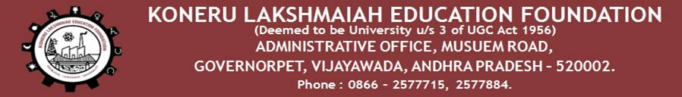

**DEPARTMENT OF COMPUTER SCIENCE & ENGINEERING**

**List of Items to be Covered in Newsletter**

1. **Department Level Activities:**
   1. Engineering, KLUBS, Hotel Management, Commerce, CAM
   2. **Workshops/Seminars /Guest lectures**

1. The department of CSE has conducted a Guest Lecture on **Design Thinking and Innovation Class on 27/07/2020 from 2:00 to 4:00 PM delivered by Mr. Sa**i.

50 faculty have particpated in the event. Design Thinking and Innovation” Organised by, KLEF, CSE Department On 20.07.2020. Mr. Sai has delivered lecture about thinking and Innovation and target participants of CSE Department, Mr. Sai dealt with various methods of Design Thinking And Innovation with simple and regular day to day life experiences. He also stated that the design thinking is an easy task and anyone can do the task with the basic knowledge of their own live examples

2. The department of CSE has organized a Guest lecture on **Design Thinking and Innovation by Prof. William Oakes Purdue University Founder of EPICS Program at Purdue on 27.07.2020.**

100 faculty have participated in the lecture. Prof. William Oakes from Purdue University , Founder of EPICS Program at Purdue has delivered lecture on Design Thinking and Innovation and target participants of CSE Department, Prof. William Oakes dealt with various methods of Design Thinking And Innovation with simple and regular day to day life experiences. He also stated that the design thinking is an easy task and anyone can do the task with the basic knowledge of their own live examples

3. The research group NSF of CSE has organized a program **Interaction with by Dr S.V. Rao, Professor IIT, Guwahati on 05.08.2020.** with the discussion of research scope in those areas

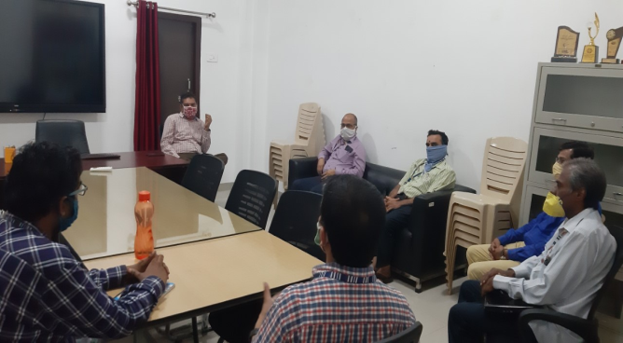 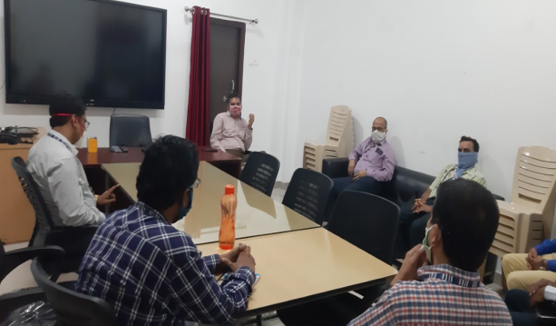

4. The department of CSE has conducted a Guest Lecture on Women Empowerment and Anti-Ragging **on 08-08-2020 delivered by** Mr. M.Madhusudhana Rao, Deputy Superintendent of Police(Rtd).

M. Madhusudhana Rao, Deputy Superintendent of Police (Rtd) addressed the Y 19 students of CSE. He spoked about the security of Women’s as well as Anti ragging. Mr. Rao has suggested some tips regarding Women’s Empowerment that includes the action of raising the status of women through education, raising awareness, literacy, and training. From his experience, he explained all about equipping and allowing women to make life-determining decisions through the different problems in society. During his lecture he has informed to students regarding any disorderly conduct whether by words spoken or written or by an act which has the effect of teasing, treating or handling with rudeness a fresher or a junior student commence under Ragging Act No. 26 of 1997. He has suggested regarding Anti-Ragging Squad in campus which should consists of a team of students, as well as teachers, can be formed in the college to fight the evil of ragging. The team should be representative in nature consisting of students from all backgrounds, grades, years, genders.

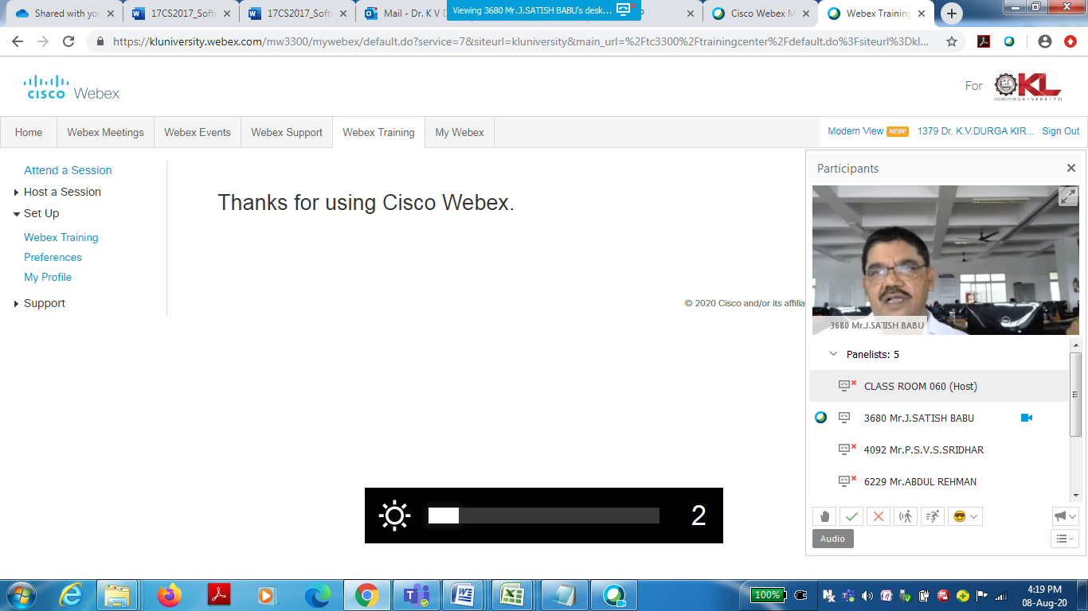

5. The department of CSE has conducted a Guest Lecture on Data Science & Big Data Analytics **on 21-08-2020 delivered by Philippe Fournier Viger, Professor, Harbin Institute of Technology, (China).**

P**rofessor Philippe Fournier Viger** from Harbin Institute of Technology, (China). He has his own blog as a personal website to discuss the opinions and ideas about data mining. professor viger is the founder and main author of the SPMF data mining soft[ware](http://www.philippe-fournier-viger.com/spmf/), an open-source software. Prof. Viger has explained about data science and pattern mining. With Apriori Algorithm professor viger has explained about pattern mining and also about data visualization. He has interacted with students and solved the query of students.

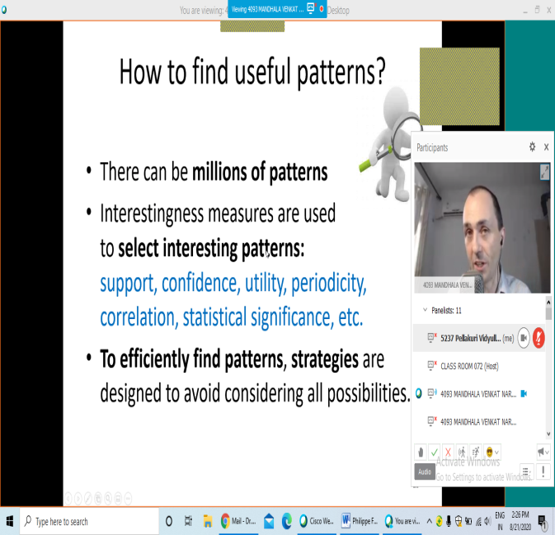 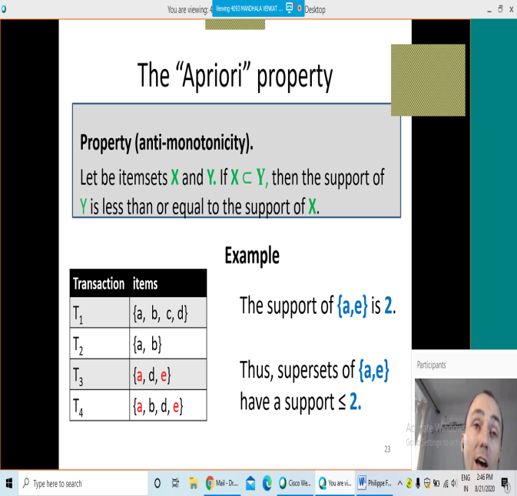

6. The department of CSE has conducted a Guest Lecture on Devops - CI/CD in AWS cloud **on 18-08-2020 delivered by** Mr. Bharat.

Mr. Bharat has explained about the topics Devops. He hasbriefly explained about the overview of version control also created a deployment environment AWS using Beanstalk. A sample code was explained to all faculties.AWS codepipeline was also introduced during lectures. The detailed topics coverd as:

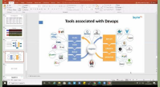

7. The department of CSE has conducted a Guest Lecture on Private Authoring in Coursera **on 22-09-2020 delivered by** Akanksha kappor and Deepak Gupta from Coursera

Ms. Akanksha kappor and Mr.Deepak Gupta spoke about how to perform Private authoring Project, Mr. Deepak briefly explained about handson for KL University faculty as demo and shows how to create the course outline and then upload the assets library and then added to course. He also explained how can we create an image of tools like Jupyter Notebook. Mr. Deepak briefly explain each steps of Coursera authoring and shows the demo to all the faculty and also solves the queries of faculties. All faculty gains knowledge and the lecture were benefitted to everyone.

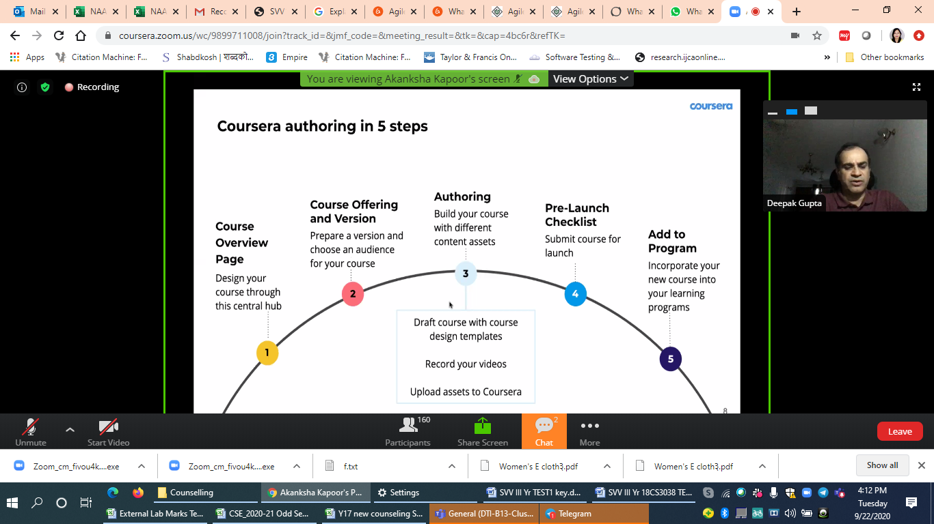

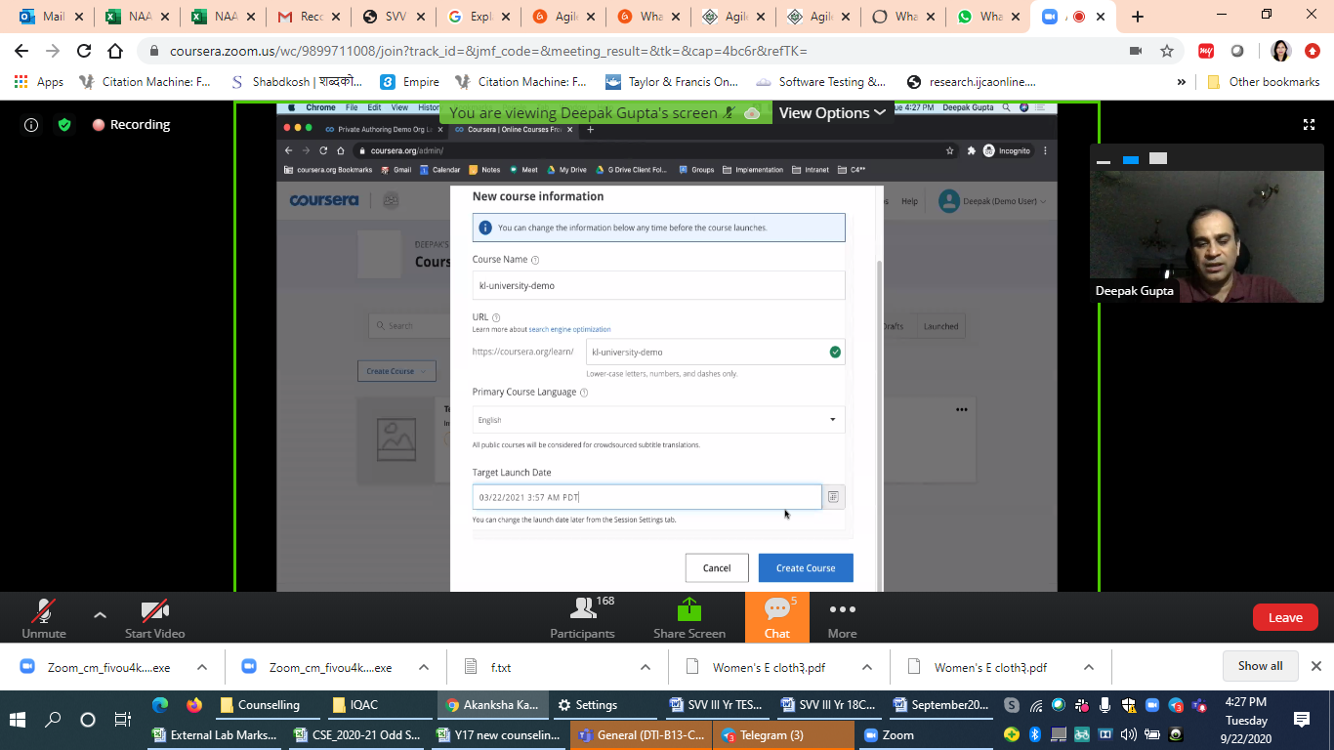

List of Faculty attended various FDPs, work shops



* 1. **Student Achievements /External participation**

**1.** KL CSE CEA conducted an online session **“EXPERT TALKS”** on 08/09/2020 at 7:00PM. The Session is about dealing with stress and complications that are being faced by students due to COVID-19 Pandemic which was delivered by Dr. SARITHA KAKANI ( MBBS , F. Diab , D. Diab, PGDD) who is currently working in Dr. Mohan’s Diabetes Specialties Centre, Vijayawada as Consultant Diabetologist. Around 80 students have attended and participated actively as the doctor cleared the doubts about the process of how to cure it, avoid it and also told what all new ways have come to cure it

2. KL CSE CEA conducted an event on SCIENCE AND PSEUDOSCIENCE on 26/09/2020 at 7:00 PM. The session is to provide knowledge of why it is said to be like that about the myths we follow in day to day life,. What causes humans to be in Pseudoscience and reasons to make rangoli and tradition of mango and turmeric leaves. The session was to unfolded the old age practices and the reason of practicing it till today without knowing the real fact about it. Around 20 students have attended the event and actively participated in the discussion

3. KL CSE CEA & HOBBY CLUBS conducted photography contest “SPIRIT OF THE PORTRAIT” to give students observation an opportunity. Photography is all about finding something interesting in an ordinary place. It has little to do with the things we see and everything to do with the way we see them. 40 students participated in this competition with zeal.

4. KL CSE-CEA & CSE-Hobby Clubs jointly conducted ART UNLIMITED which is planned to provide the students with, as a way to let their regular exhaustion out of their minds onto the paper, and also to rejuvenate their creative spirits by putting their brushes to test. Around 30 students participated and show cased their ARTS

5. KL CSE CEA along with White Hat Club conducted an Ethical Hacking Webinar on 29/08/2020 at 7:00 PM. Around 900 Students participated in the webinar who gained knowledge about the basics of Ethical Hacking and Cyber Security.

6. Hobby Clubs along with CEA conducted an essay writing competition on 29/08/2020 at 6:00PM. The participants were made to present their writing skills on theme POST COVID TIMES.

7. The CSE-CEA has conduced an event on ANTI RAGGING on 08/08/2020. to create awareness among students about Ragging in college and consequences that students face.

8. **Vardhan GSS(180030220)** is a certified Ethical Hacker from EC-Councl on 21/08/2020

9. **Siddhardha Goparaju(180030337)** is a certified Ethical Hacker from EC-Councl on 21/08/2020

10. B.T.V.S.R Phaneendra(180030150) is a certified Ethical Hacker from EC-Councl on 21/08/2020

11. Vivek Raj(180030123) is a certified Ethical Hacker from EC-Councl on 21/08/2020

12. FOCUS a Student body of CSE has conducted Engineers Day-2020 on 15/09/2020 from 7:00 PM

If not for those large charts with indecipherable building plans, super-fast computers with mind-boggling programs, baffling circuit boards with electrical designs, the world would still have been in the Stone Age. The evolution human beings have undergone with the world around them becoming increasingly broad and creative, is a defining period of the human timeline. The success of the advancements being made in the current digital panorama should be etched on the wall of victory of the Engineers. With this never-ending chain of achievements enthralling the entire world, the official student body of the Department of Computer Science and Engineering, FOCUS, has organized Engineer’s Day Celebrations on 15th September, 2020 on account of Engineer’s Day.

The chief Guest Mr. Surya Chandra Sekhar, Chief Data Scientist at Selector Software, Sunnyvale, California. He has a 20+ year-experience in system architecture, design and implementation of software for network elements and operations, with his current focus being applying data sciences to build product differentiators in the space of network operations and IoT. Also present as chief guest was Mr. Sankar Sripada, Director of Engineering, Quality at SAP Ariba, Bengaluru, Karnataka. He is a hands-on engineering leader in leading innovation, driving change, building engagement, and creating positive cultures. He is an accomplished leader with general management experience including test planning, risk analysis, metrics reporting, budgeting, project management, resource planning, and onshore & offshore teams.

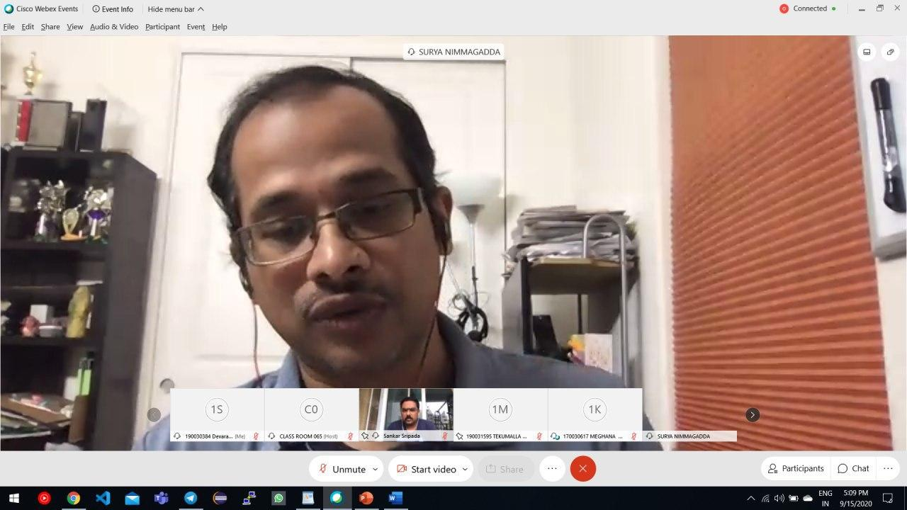

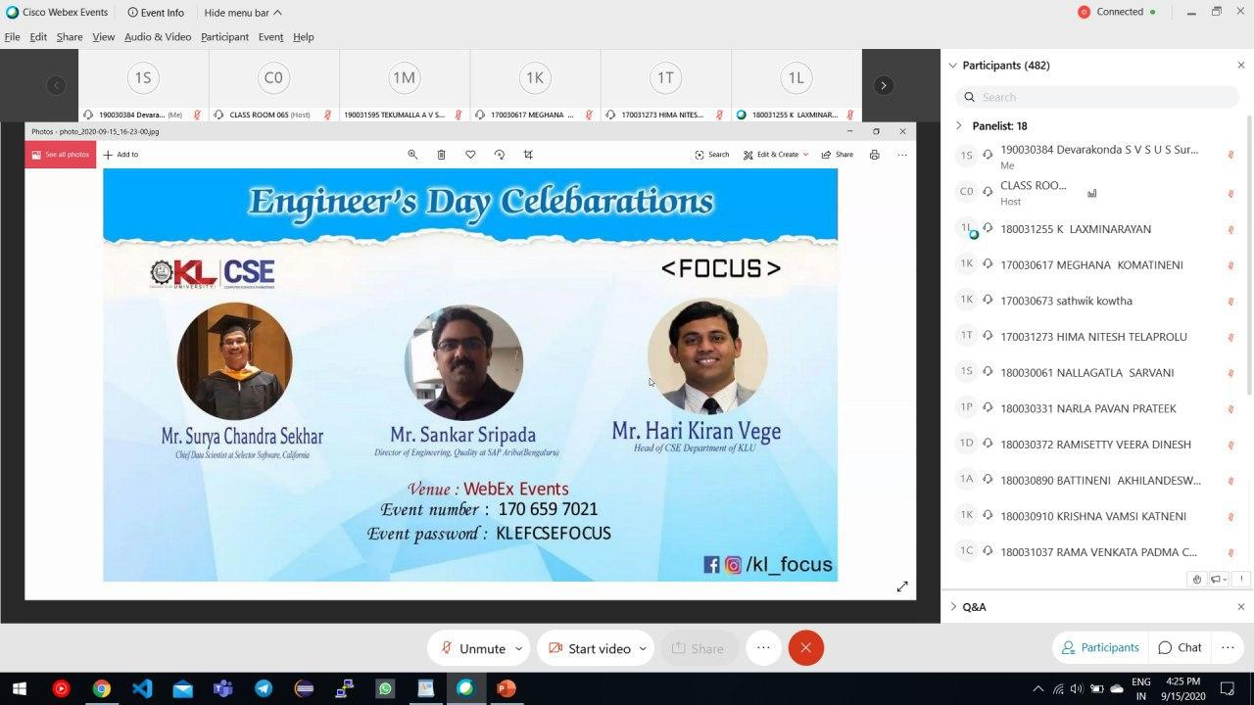 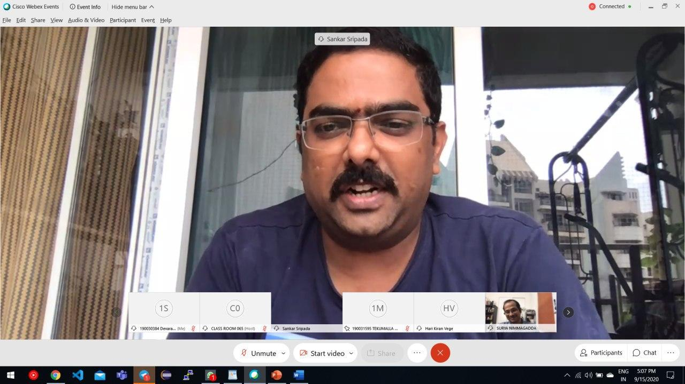

13. FOCUS a Student body of CSE has conducted GURUVEDIC-2020 on 20/09/2020 from 5:00 PM

In a world as vast and complicated as this, it is a man’s necessity and essential to look for a hand to hold his and guide him through the way of life, to his destiny. Life gives you many teachers before becoming one. In every phase of a man’s life, someone or something is truly needed to shed light on the path ahead. But it is our fortune that we have a great culture of celebrating the existence of such elements in our lives and the humility to acknowledge that our lives would be of no value without them. A manifestation of that very tradition is what brought us all here today.

The faculty members in the CSE Department are no less diligent than this, in fact, they’re even more dedicated and visionary. If the success of the students in the department can be considered a legit reflection of the brilliance of the eminent faculty behind it, then the records speak for themselves.

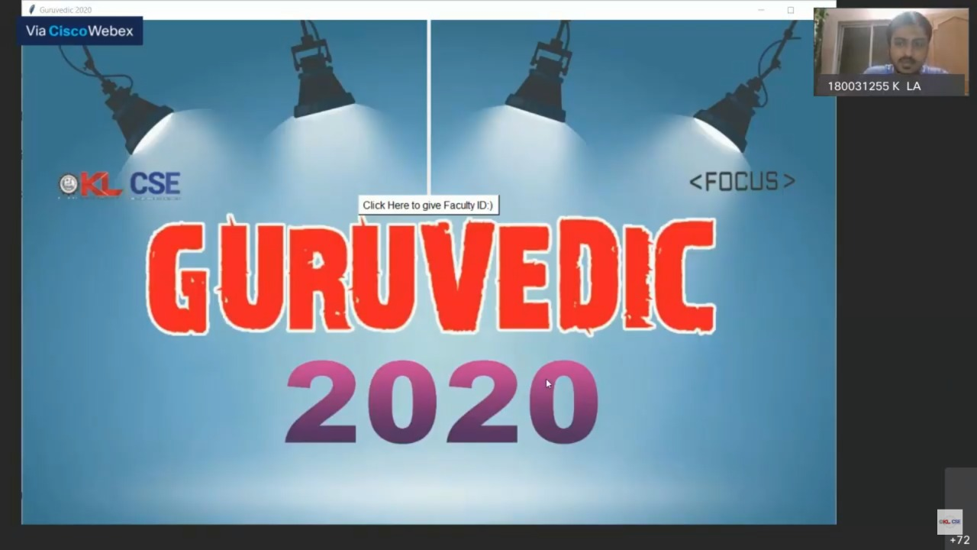

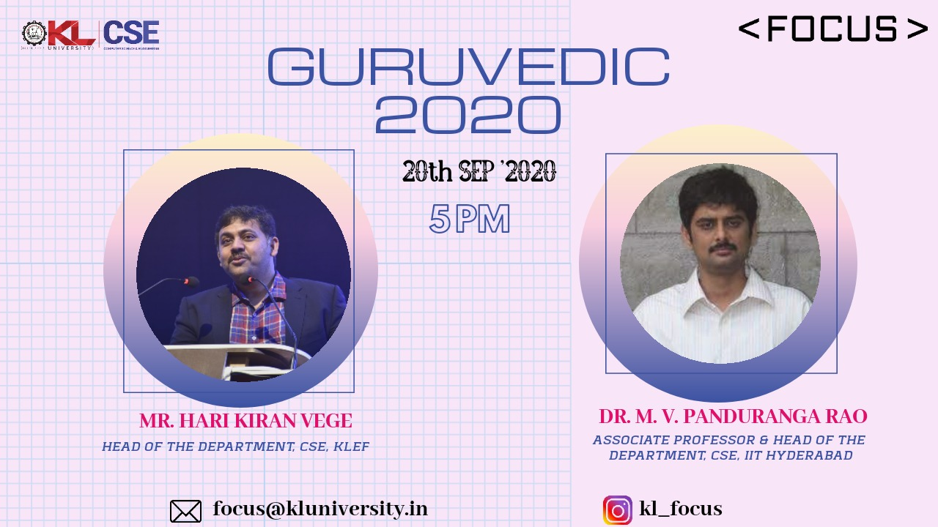

The chief guest of the evening was Dr. M. V. Panduranga Rao, Assoc. Professor and Head of the Deparatment of CSE at IIT Hyderabad. A highly revered faculty member in the institution has addressed the faculty and the students.

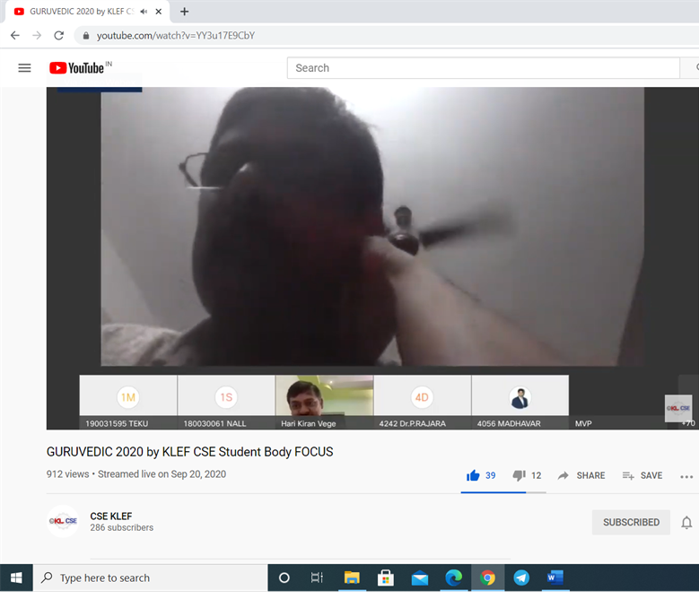

List of the Students participated in various events



* 1. **Department’s Recognition – at National / International Level**

**NIL**

* 1. **Webinars – Students**

**1. Mr. Bradd Feng & Mr. Danny Lin** Director, Global Talent Ecosystem Development Department Huawei Technologies Co., Ltd.deliverd the webinaron **"﻿Industry Academy Collaboration – Huawei ICT Academy”**  that wasconducted on 08/07/2020 at 5:30PM

**2. Dr. Marlene Kanga** Past-President World Federation of Engineering Organisations (WFEO) delivered the webinaron **“Re-setting the Benchmarks for Engineering Graduates**

**with the Right Skills for Sustainable Development”**  that was**conducted** on 15/07/2020 at 5:30PM

**3. Arnold Offner** Strategic Marketing Manager ﻿Process Automation Infrastructure

Phoenix Contact USA deliverd the webinaron **“Empowering the All Electric Society”**  that wasconducted on 22/07/2020 at 5:50 PM

**4. Clive Hands and Charl Rossou**w Nelson Mandela University, SA Partner: ALTAIR delivered the webinaron **Virtual Project-Based Learning (PBL) involving Computer-Aided Engineering (CAE) and Data Analytics** that was**conducted** on 29/07/2020 at 5:50 PM

**5. Dr. Sunil Jha** IIT Delhideliverd the webinaron **“Overview of Smart Manufacturing Confirmation”**  that wasconducted on 31/07/2020 at 3:00 PM

**6. Mr. R. Nithish kumar** Coimbatore Institute of Technology deliverd the webinaron **“EWB India - IUCEE Webinar 11 - “Bio Digester” and “Water Management In smart cities”**

that wasconducted on 08/08/2020 at 5:00 PM

**7. David Willingham** Senior Product Manager Mathworks delivered the webinaron **“Teaching AI(Artificial Intelligence)with MATLAB”** that wasconducted on 12/08/2020 at 5:00PM

**8. Nitin Rai** application engineer MathWorks India delivered a **“Improve ASIC and FPGA Verification Productivity by Connecting to MATLAB and Simulink”** that was conducted on 13/08/2020 at 3:00 PM

**9. Spandhana Gonuguntla** Education Technical Evangelist MathWorks Indiadeliverd the webinaron “**Framework for Automatic Assessment and Evaluation of MATLAB Assignments and Examinations Using MATLAB Grader”** that wasconditucted  on 17/08/2020 at 3:15 PM

**10. Rick Gentile MathWorks** deliverd the webinaron **“Deep Learning for Radar and Wireless Communications”**  that wasconducted on 18/08/2020 at 4:00 PM

**11. Dr. Souvick Chatterjee MathWorks** India deliverd the webinaron **“Virtual Labs for Mechanical Engineering”** that wasconducted  on 24/08/2020 at 3:15 PM

**12. Dr. Manel Martínez-Ramón** Department of Electrical and Computer Engineering

University of New Mexicodeliverd the webinaron **“Machine Learning:from Data to Knowledge”** that wasconducted on 26/08/2020 at 6:00 PM

**13. Dr.Viacheslav Merkin** deliverd the webinaron **“Mysteries fo geospace storms”** that wasconducted on 09/09/2020 at 5:30 PM

**14.** The faculty of CSE have attended the webinar on **“Virtual Labs for Cybersecurity”** conducted by IUCEE on 16/09/2020 at 4:30 PM

**15.** **Dr. Gilbert Lai & John Pineros Quanser** Canada deliverd the webinaron **“More Flexibility for Self-Driving Vehicles Research: Integrating QCar and MATLAB Toolboxes”**  that wasconducted on 16/09/2020 at 5:30 PM

**16.** **Dr. Vijay Kanabar** Director of Project Management Associate Professor Boston University deliverd the webinaron **“Creating An Agile Mindset and Innovation”** that wasconducted on 16/09/2020 at 6:30 PM

**17.** The faculty of CSE have attended the webinar on **“Intro to Social Proton Remote Labs”** conducted by IUCEE on 17/09/2020 at 4:00 PM

**18.** **Dr. Danielle Robinson and Dr. Franz Newland** deliverd the webinaron **“Airbus GEDC Diversity Award”** that wasconducted on 23/09/2020 at 5:30 PM

19. **Sandra B. Richtermeyer**, Ph.D. Dean, Manning School of Business University of Massachusetts Lowell deliverd the webinaron **“Creating and Sustaining an Advisory Board: A Key Success Factor for an Entrepreneur”** that wasconducted on 30/09/2020 at 5:30 PM

* 1. **Research**

**Publications:**

1.Debnath Bhattacharyya, Nakka Marline Joys Kumari, Eali Stephen Neal Joshua, N. Thirupathi Rao published a paper entitled **“Advanced Empirical Studies on Group Governance of the Novel Corona Virus, MERS, SARS and EBOLA: A Systematic Study”** in International Journal of Current Research and Review – Scopus Indexed ISSN: 2231-2196

2. Nageswarara Rao Moparthi, P. Vidya Sagar, G. Balakrishna published a paper entitled **“Usage for Inside Design by AR and VR Technology”** in IEEE 7th International Conference on Smart Structures and Systems ICSSS 2020 – Scopus Indexed ISSN: 978-1-7281-7223-1

3. Stephen, Midhunchakkravarthy, Debnath Bhattacharyya published a paper entitled  **“AN EXTENSIVE REVIEW ON LUNG CANCER DETECTION USING MACHINE LEARNING TECHNIQUES”** in International Information and Engineering Technology Association (IIETA) – Scopus Indexed ISSN: 1258-5769

4. Dr. C. S. Prakash published a paper entitled **“Low Dimensional DCT and DWT Feature-based Model for Detection of Image Splicing and Copy-move Forgery”** in Multimedia Tools and Applications (SCIE) – Springer ISSN: 2049-3630 with impact factor 2.313

5. Ega Soujanya LAKSHMI, Manda Rama Narasinga Rao; Muddada Sudhamani published a paper entitled **“RESPONSE SURFACE METHODOLOGY-ARTIFICIAL NEURAL NETWORK-BASED OPTIMIZATION AND STRAIN IMPROVEMENT OF CELLULASE PRODUCTION BY STREPTOMYCES SP.”** in Bioscience Journal – Scopus Indexed ISSN: 1390-1402 with impact factor 5.378

6. Anjali Mathur, G. Prem Rishi Kranth, Laharika Basava, Maneesh Alla published a paper entitled **“QUALITY ANALYSIS OF TEA WITH THE HELP OF MACHINE LEARNING ALGORITHMS”** in International Research Journal of Engineering and Technology (IRJET)– Scopus Indexed ISSN: 2395-0056 with impact factor 7.5

7. Dr. JKR Sastry, B. TrinathBasu published a paper entitled **“Implementing User defined Attribute and Policy based Access Control within OpenStack”** in International Journal of Emerging Trends in Engineering Research – Scopus Indexed ISSN: 3271 - 3279

8. Dr. JKR Sastry, B. TrinathBasu published a paper entitled **“Implementing User defined Attribute and Policy based Access Control”** in International Journal of Emerging Trends in Engineering Research - Scopus Indexed ISSN: 2347 – 3983

9. Pilla Srinivas, Debnath Bhattacharyya, Divya Midhun Chakkaravarthy published a paper entitled **“An Artificial Intelligent based System for Efficient Swine Flu Prediction using Naive Bayesian Classifier”** in International Journal of Current Research and Review – Scopus Indexed DOI: http://dx.doi.org/10.31782/IJCRR.2020.121519

10. V.Valli Kumari, Ram Prasad Reddy Sadi published a paper entitled **“(k,l)f-Anonymity: A Federated Learning Approach for Personalized Privacy Preserving Data Publishing”** in Journal of Advanced Research in Dynamical and Control Systems – Scopus Indexed ISSN: 1943-023X

11.Vamsidhar Talasila, Chitturi Prasad, Guttikonda Trinesh Sagar Reddy, Allada Aparna published a paper entitled **“Analysis and Prediction of Crop Production in Andhra Region using Deep Convolutional Regression Network”** in International Journal of Intelligent Engineering and Systems – Scopus Indexed DOI: 10.22266/ijies2020.1031.01

12. Vamsidhar Talasila, Kotakonda Madhubabu, Meghana Chakravarthy, Mahadasyam, Naga Jyothi Atchala, Lakshmi Sowjanya Kande published a paper entitled **“The Prediction of Diseases using Rough Set Theory with Recurrent Neural Network in Big Data Analytics”** in International Journal of Intelligent Engineering and Systems - Scopus Indexed DOI: 10.22266/ijies2020.1031.02

* 1. **Projects/Patents:**

1. **G. Vijay Kumar** applied for a project with title **“Training Program on Entrepreneurship”** under **DST**

2. **Dr. Debnath Bhattacharyya** applied for a project with title “**Diagnosis of Erythrocytes infected with Malaria Parasite using Microscopic Images”** under A**SEAN-India Collaborative R&D**